Dr. Atul Dhar
Assistant Professor
School of Engineering, Indian Institute of Technology Mandi, Mandi
----------------------------------------------------------------------------------------------------------------------------------------------
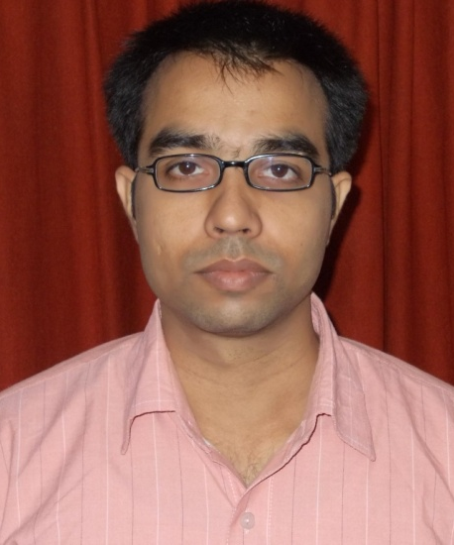
Phone : 01905-237993
Email : add[at]iitmandi[dot]ac[dot]in
Address: School of Engineering,
IIT Mandi, PWD Rest House 2nd floor,
Near Bus Stand, Mandi, Himachal Pradesh,
India – 175001

Research Interests
Alternative Fuels: Biodiesel, Biogas, Hydrogen, CNG
Engine Emission Control
Engine Management and Control
Combustion Diagnostics and Instrumentation
Particulate Characterization and Control
Long Term Engine Wear and Durability
Lubricating Oil Tribology

Education
B.Tech. in Mechanical Engineering (2004) from HBTI, Kanpur
M.Tech. in Mechanical Engineering (2006) from Indian Institute of Technology Kanpur, Kanpur
Ph.D. in Mechanical Engineering (2013) from Indian Institute of Technology Kanpur, Kanpur

Work Experience
Assistant Professor, Indian Institute of Technology Mandi, December 2013-Present
Senior Research Associate (Pool Scientist- CSIR), Indian Institute of Technology Kanpur, December 2011-November 2013

Publications
Book Chapters
- Avinash Kumar Agarwal, Atul Dhar, “Performance, Emission and Combustion Characteristics of Preheated and Blended Jatropha Oil”, in Book: Jatropha, Challenges for a New Energy Crop Volume 1: Farming, Economics and Biofuel, pp. 491-508, Springer New York, 2012, ISBN: 978-1-4614-4806-8.

Refereed Journal Papers
- Atul Dhar, Vishal Saxena, Avinash Kumar Agarwal, "Measurement of Dynamic Lubricating Oil Film Thickness between Piston Ring and Liner in a Motored Engine" Sensors and Actuators, Volume 149, Issue 1, January 2009, pp. 7-15 (ISSN # 0924-4247)
- Avinash Kumar Agarwal, Atul Dhar, "Performance, Emission and Combustion Characteristics of Jatropha Oil Blends in a Direct Injection Engine" SAE 2009-01-0947, SAE Special Publication SP-2239, 2009 (ISBN # 978-0-7680-2135-6)
- Avinash Kumar Agarwal, Atul Dhar, "Karanja Oil Utilization in DI Engine by Preheating: Experimental Investigations of Engine Performance, Emissions and Combustion Characteristics, Part I", Proc. IMechE Part D: J. Automobile Engineering, Vol. 224, pp. 73-84, June 2009 (ISSN # 09544070)
- Avinash Kumar Agarwal, Atul Dhar, "Karanja Oil Utilization in DI Engine by Preheating: Experimental Investigations of Engine Durability and Lubricating Oil Properties Part II", Proc. IMechE Part D: J. Automobile Engineering, Vol. 224, pp. 85-97, June 2009, DOI: 10.1243/09544070JAUTO1267
- Avinash Kumar Agarwal, Atul Dhar, "Experimental Investigation of Preheated Jatropha Oil Fuelled Direct Injection Compression Ignition Engine: Part-I, Performance, Emission and Combustion Characteristics" Journal of ASTM International, Vol. 7, No. 6, Paper ID JAI102414, June 2009
- Avinash Kumar Agarwal, Atul Dhar, "Experimental Investigation of Preheated Jatropha Oil Fuelled Direct Injection Compression Ignition Engine: Part-II, Engine Durability and Effect on Lubricating Oil" Journal of ASTM International, Vol.7, No. 2, Paper ID JAI102415, March, 2009
- Avinash Kumar Agarwal, Atul Dhar, "Comparative Performance, Emission and Combustion Characteristics of Rice-bran Oil and Its Biodiesel in a Transportation Diesel Engine", Journal of Engineering for Gas Turbine and Power, Transactions of ASME, Volume 132, pp. 064503-1-4, June, 2010 (ISSN # 0742-4795)
- Avinash Kumar Agarwal, Atul Dhar, “Performance, Emissions and Combustion Characterization of Biodiesel in a Generator Engine”, International Energy Journal, Volume 12, Issue 2, June 2011
- Atul Dhar, Roblet Kevin, Avinash Kumar Agarwal, “Production of Biodiesel from High-FFA Neem oil and Its Performance, Emission and Combustion Characterization in a Single Cylinder DICI engine”, Fuel Processing Technology, Volume 97, May 2012, Pp. 118–129
- Avinash Kumar Agarwal , Atul Dhar, “Wear, durability, and lubricating oil performance of a straight vegetable oil (Karanja) blend fueled direct injection compression ignition engine”, Journal of Renewable and Sustainable Energy, Volume 4 (6), art no. 063138 http://dx.doi.org/10.1063/1.4771694, 2012
- Avinash Kumar Agarwal, Atul Dhar, “Experimental investigations of performance, emission and combustion characteristics of Karanja oil blends fuelled DICI engine”, Renewable Energy, Volume 52, April 2013, Pp. 283-291
- Avinash Kumar Agarwal, Atul Dhar, Dhananjay Kumar Srivastava, Rakesh Kumar Maurya, Akhilendra Pratap Singh, “Effect of fuel injection pressure on diesel particulate size and number distribution in a CRDI single cylinder”, Fuel, Volume 107, May 2013, Pages 84-89
- Avinash Kumar Agarwal, Dhananjay Kumar Srivastava, Atul Dhar, Rakesh Kumar Maurya, Pravesh Chandra Shukla, Akhilendra Pratap Singh, “Effect of fuel injection timing and pressure on combustion, emissions and performance characteristics of a single cylinder diesel engine”, Fuel, volume 111, 2013, pp. 374-383
- Paras Gupta, Atul Dhar, Avinash Kumar Agarwal, “Experimental investigations of a single cylinder genset engine with common rail fuel injection system”, Thermal Science (ISSN 2334-7163), 2013, 2013doi: 10.2298/TSCI130219083G
- Atul Dhar, Avinash Kumar Agarwal, “Performance, emissions and combustion characteristics of Karanja biodiesel in a transportation engine” Fuel 119, 2014 pp. 70-80

Refereed Conference Papers
- Atul Dhar, Avinash Kumar Agarwal, “Effect of Multiple Injections on Particulate Size-Number Distributions in a Common Rail Direct Injection Engine Fueled with Karanja Biodiesel Blends” SAE Paper 2013-01-1554, SAE International World Conference, April 2013, Detroit, USA
- Avinash Kumar Agarwal, Atul Dhar, “Experimental Investigations of Engine Durability and Lubricating Oil Properties of Jatropha Oil Blends Fuelled DI Diesel Engine”, ASME Conf. Proc. ICEF2009 (2009), ASME 2009 Internal Combustion Engine Division Fall Technical Conference, September 2009, Lucerne, Switzerland
- Avinash Kumar Agarwal, Atul Dhar, “Performance, Emission and Combustion Characteristics of Jatropha Oil Blends in a Direct Injection Engine”, SAE Paper 2009-01-0947, SAE International World Conference, April 2009, Detroit, USA
- Atul Dhar, Avinash Kumar Agarwal, Vishal Saxena "Measurement of Lubricating Oil Film Thickness between Piston Ring-liner Interface in an Engine Simulator", SAE Paper No. 2008-28-0071, SAE INDIA International Mobility Conference-2008, pp. 494-499, January 2008, New Delhi, India

Teaching

